# Multi - purpose Drone

# Fertilizer Drone / Fire Extinguisher

**Authors : - 1. Yash .D. Kalam**

**2. Prajwal .B. Yadav**

**3.Udaykumar S Gadikar**

**Email –** [**deelip.yash@walchandsangli.ac.in**](mailto:deelip.yash@walchandsangli.ac.in)

[**prajwal.yadav@walchandsangli.ac.in**](mailto:prajwal.yadav@walchandsangli.ac.in)

[udaykumar.gadikar@walchandsangli.ac.in](mailto:udaykumar.gadikar@walchandsangli.ac.in)

**Abstract :-**

The purpose is to develop Droner which carries pesticides to spray all over the farm , also this drone is design in such way that its carries water and we can use it as Fire Extinguisher in emergency. Our aim is to make a drone in such a way that it will reduces the cost by 30% from its actual price .

**Introduction : -**

As we know ,the application of fertilizers and pesticides in agricultural areas is of prime importance for crop yields, so The use of aircrafts is becoming common for performing task because of the speed, accuracy and effectiveness in spraying operation. The farmers are using the spraying bags to spray pesticides all over the farm. but The farmers have to carry the pesticide spraying bag which makes them get strained. Even the farmers are unable to evenly distribute the pesticides all over the farm, also it will be time consuming.The farmer can spray the pesticides using drone evenly all over the field . very quickly .It reduces the workload of the farmers and also completes the work very fast. Our pesticides/fertilizers spraying done will find its massive application in providing pesticides over a large area of land for farmer. It is highly efficient and of low cost. It is reliable for liquid pesticides and fertilizers. The mode of operation of out drone makes it easy to handle.It is controlled with the android based mobile app.

Spraying of Pesticides/ Fertilizer via Drone for Agricultural purpose

**Objective : -**

1. To spray fertilizers and pesticides within short time span using drone .

2. To make a drone capable of carring water upto particular height.

3. To optimize the price by 30% .

4. To study fundamentals of drones(different components of drone).

**Methodology**

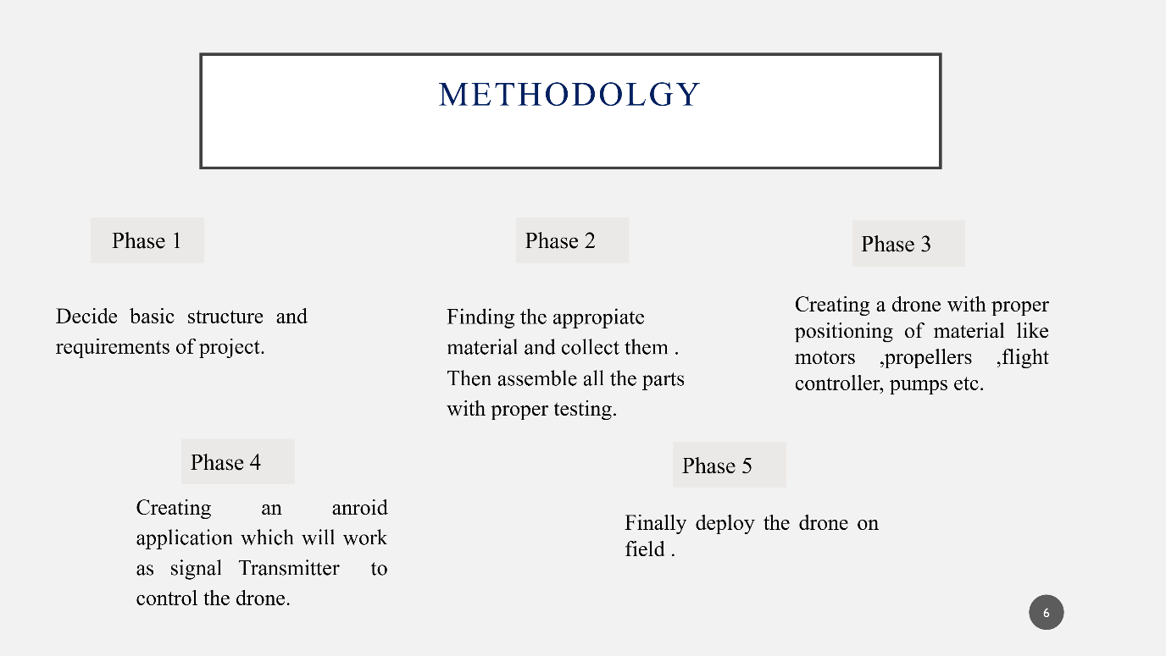

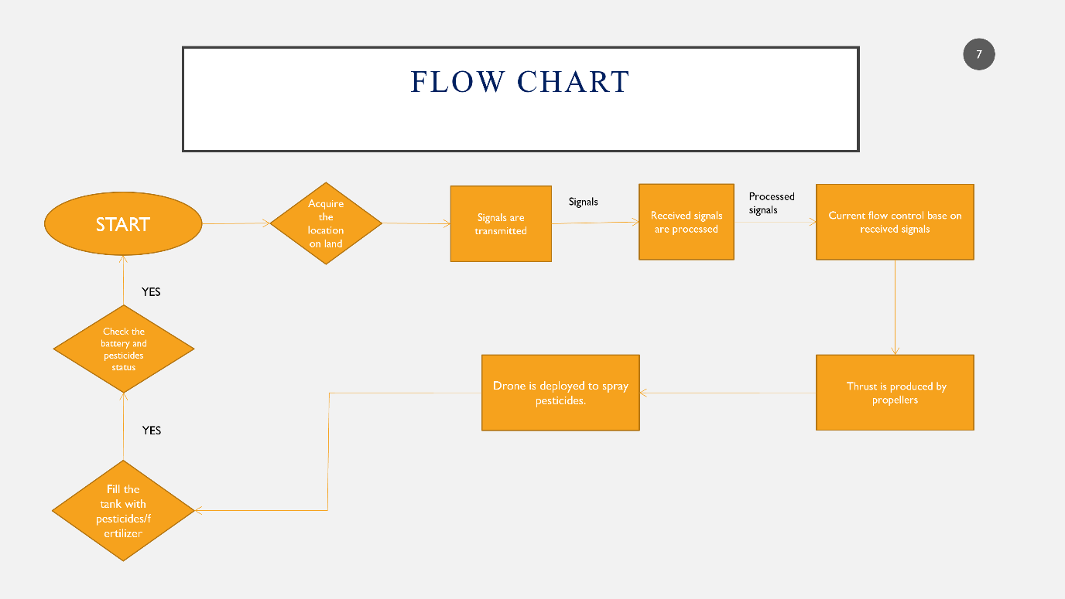

**Technology Stack**

**SOFTWARE & HARDWARE SPECIFICATION**

**Hardware -:**

Drone frame , Flight controller ,Propellers ,

Pump ,Spray parts ,Battery 5200mah ,Charger for the battery ,

receiver ,ESC 40amp, Power distribution board ,

Disc motor.

**SOFTWARE:**

Android Application

Framework : React native

Java Programming

Database : - Firebase

**Results : -**

1. Our drone is capable of spraying fertilizer our farm in less time and efficient manner.
2. This drone will help in emergency
3. This drone will serve a lot in agricultural fields .
4. The application will be user – friendly, cost-effective (one time investment).

**Conclusion : -**

1. The Freyr Drone will help the farmer to spray the pesticides all over his land ,which will be an alternative for carrying pesticides bags
2. This will boost the research and technique in agriculture field .
3. It reduces the work of farmers as here the farmer can control the drone using an android app.
4. It will precisely route the famer’s land using GPS no matter shape of the field and type of the crop, the drone will get the job done.

**References : -**

<https://ieeexplore.ieee.org/document/7972289>

<https://youtu.be/4gGMMPMm9MQ>

<http://www.thanos.in/products/>

<https://aero-drone.in/>